**Multiple screenshots of failure and success from Ci**

**Flutter Build**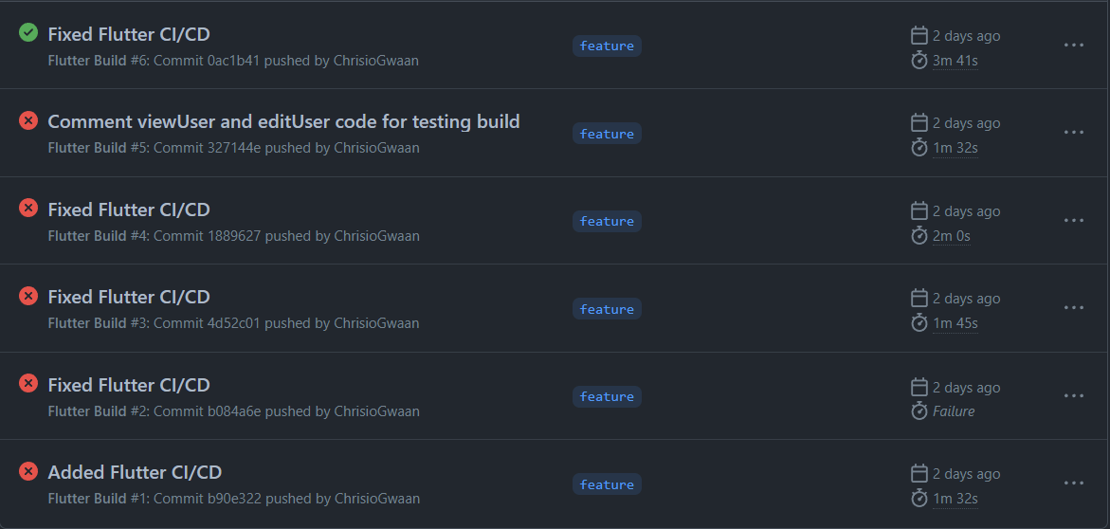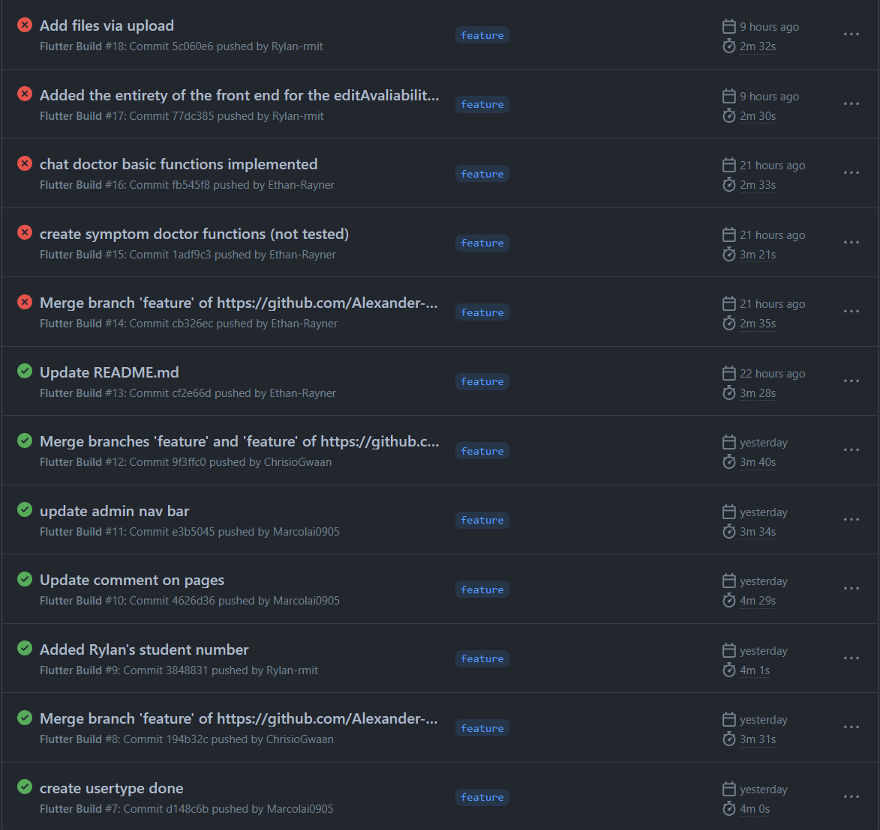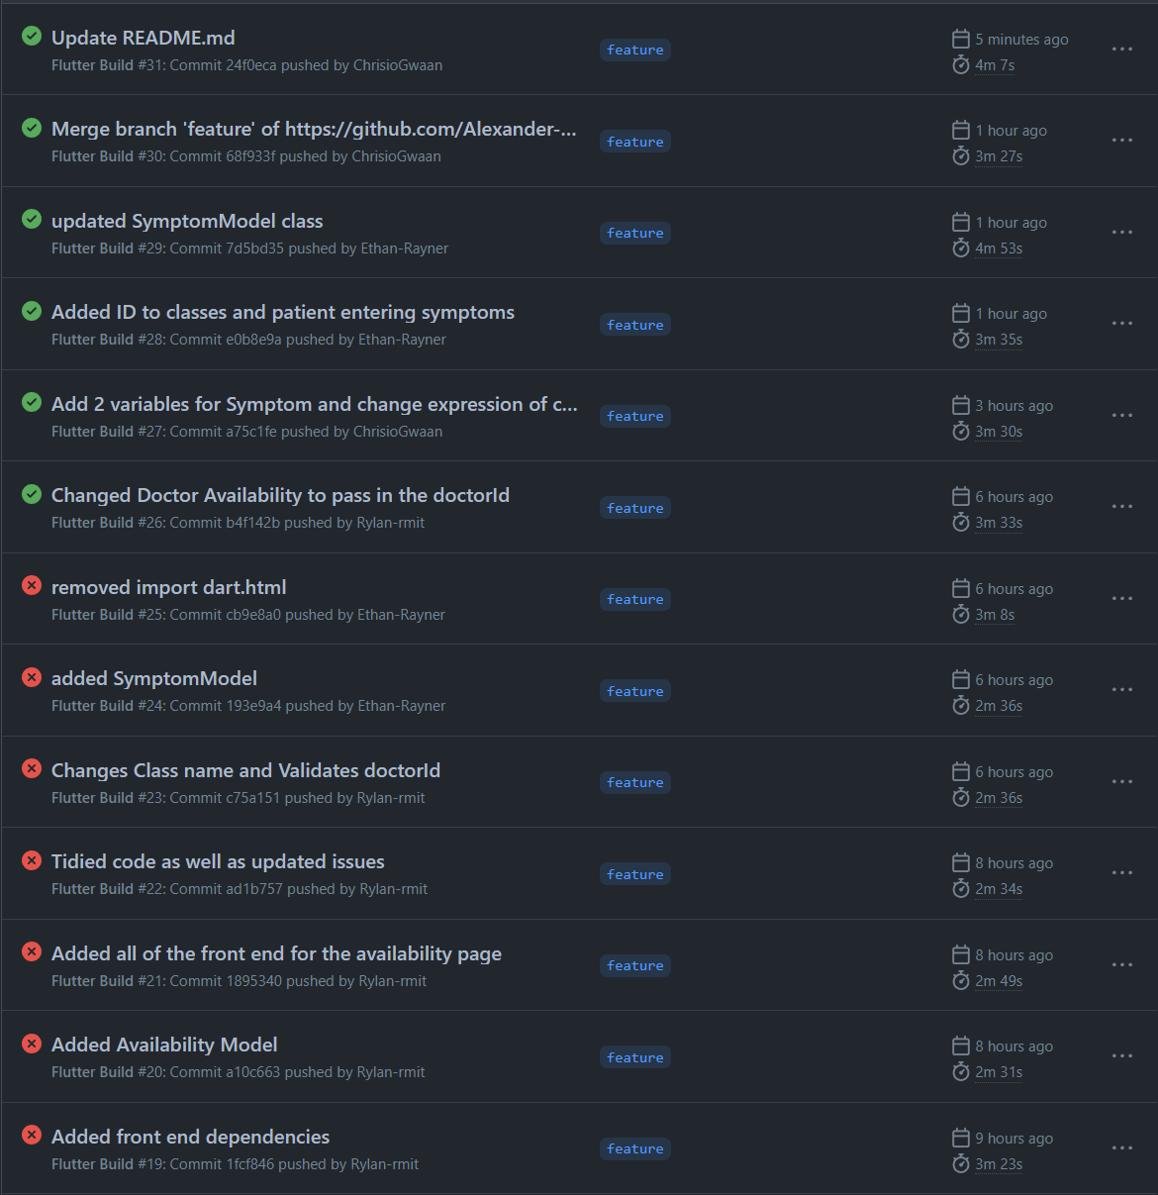

**Java CI with Maven**



